**DDL COMMANDS**

* CREATE
* DROP
* ALTER
* TRUNCATE

create table testTable(ID int Primary key, DataValue varchar(30));

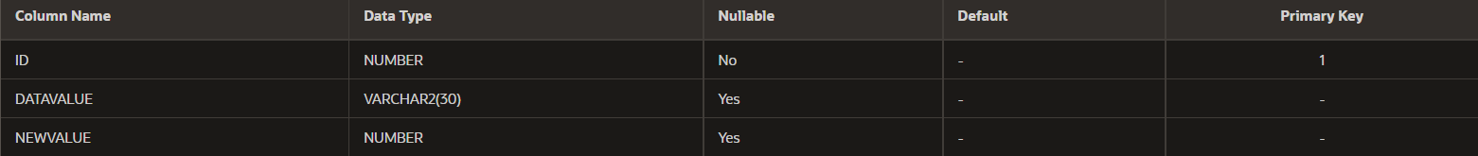ALTER TABLE testTable ADD(NewValue int);

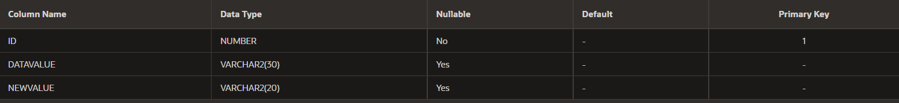ALTER TABLE testTable MODIFY newValue varchar(20);

ALTER TABLE testTable DROP COLUMN newValue;

TRUNCATE TABLE testTable;

**DML COMMANDS**

* INSERT
* UPDATE
* DELETE
* SELECT

insert into testTable(ID,dataValue)VALUES('1','ABC');

UPDATE testTable SET ID='2' WHERE ID='1';



DELETE FROM testTable WHERE ID='2';

SELECT * FROM testTable;

**Imposing restrictions on database (DCL & TCL Commands)**

**DATA CONTROL LANGUAGE(DCL)**

* GRANT
* REVOKE

**TCL COMMANDS**

* COMMIT
* ROLLBACL
* SAVEPOINT

create database testing;

use testing;

create table testTable(ID INT PRIMARY KEY,dataValue varchar(30));

INSERT INTO testTable VALUES(2,"ABC");

COMMIT;

UPDATE testTable SET ID=11 WHERE ID=2;

SELECT * FROM testTable;

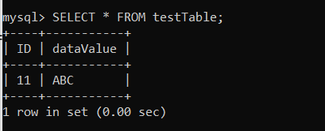

START TRANSACTION;

SAVEPOINT A;

INSERT INTO testTable VALUES(4,"ABCDE");

SELECT * FROM testTable;

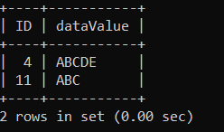

ROLLBACK TO A;

SELECT * FROM testTable;

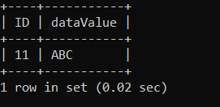

**Accessing database (SELECT, Filtering using WHERE, HAVING, GROUP BY, ORDER BY Clauses, Subquery and View)**